

Report

Module Title: Computer Vision and AI Level
Module Code: CMS22202

Submitted by:
Md Akiduzzaman Arnob
98088024

Title
Automated Visual Intrusion Detection in Precision Livestock Farming Using Custom Convolutional Neural Networks (CNNs): A Data-Driven Approach to Agricultural Security and Monitoring

Table of Contents
1. INTRODUCTION/BACKGROUND 4
1.1 Objective 4
1.2 Problem Definition 4
1.3 Importance of the Problem 4
1.4 Literature Review 5
1.5 Objectives and Scope 5
2. DATA EXPLORATION 6
2.1 Data Overview 6
2.2 Class Distribution and Imbalance 6
2.3 Visualizations and Patterns 7
2.4 Data Issues & Handling 8
2.4.1 Inconsistent Resolutions 8
3. METHODOLOGY 9
3.1 Data Preprocessing 9
3.2 Rescaling 9
3.3 Data Partitioning 9
3.4 Data Augmentation 9
3.5 Model Selection 10
3.6 Architecture Design 10
3.7 Hyperparameter Tuning and Training Process. 11
3.8 Intrusion Detection Logic 12
4. EVALUATION, CONCLUSION, AND FUTURE IMPROVEMENTS 13
4.1 Evaluation Metrics 13
4.2 Results and Analysis 13
4.3 Limitations 15
4.4 Future Improvements 15
4.5 Conclusion 16
5. References 17

List of Figures
Figure 1 Class distribution showing the imbalance between 'Cane' (Dog) and 'Elefante 7
Figure 2 Sample images demonstrating variance in background, scale, and lighting. 7
Figure 3 Confusion Matrix highlighting misclassifications between Horses and Cows. 14
Figure 4 Training graphs showing convergence and lack of overfitting. 15

List of Tables
Table 1 Data Handling and Issues 8
Table 2 Preprocessing techniques and purposes 10
Table 3 Design parameters 11
Table 4 Hyperparameter Tuning and Training 11
Table 5 Key Matrices 13
Table 6 Key results 14

1. INTRODUCTION/BACKGROUND

1.1 Objective
The major objective of this semester project is to design, implement and evaluate a computer-vision system to identify animals in order to develop an automated "Smart Farm Security System". The idea is to take a visual stream from the perimeter of a farm and enter it into the system and have it identify authorized livestock - sheep, cows, chickens - versus things that may harm us, such as a spider or a wild animal. We're going to be trying to reach a Convolutional Neural Network (CNN) trying to classify images into ten categories.

1.2 Problem Definition
Constant monitoring of animals and fields is tedious, inaccurate, and uncommon when dealing with large areas of land, and because of this, predators or pests can get into grazing fields without being noticed, and groups of animals can be scattered without prior warning. Traditional motion-detection sensors (e.g. plain cameras or PIR sensors) are prone to raise alarms whenever there is any motion including harmless ones such as wind-blown trees or non-threatening wildlife and result in frequent false alarms (i.e. alarm fatigue). According to Semenov et al. (2025), the introduction of intelligent monitoring to machine learning and IoT into digital farms can result in timely, precise, and context-sensitive anomalies or intrusion detection.

1.3 Importance of the Problem
This issue is significant as the farms do not always have the labour force and sufficient attention to control extensive pastures. Manual livestock monitoring is expensive, labour intensive and non-scalable to large herds as mentioned by Bello and Olubummo (2024). An automated visual-monitoring system will resolve this scalability problem and minimise the amount of labour, as well as financial risk, caused by predation or pest intrusion. Also, automated monitoring of animal behaviour and the environment with sensors and computer vision is becoming increasingly popular in the Precision Livestock Farming (PLF) field to enhance livestock operations in terms of welfare, productivity, and sustainability.

1.4 Literature Review
Previous studies in computer vision used features which had to be developed by hand like Scale-Invariant Feature Transform (SIFT) by Lowe (2004) and Histogram of Oriented Gradients (HOG) by Dalal and Triggs (2005). These techniques however, were very sensitive to lighting, scale, and occlusion, which restricted their strength in real life systems. LeCun et al. (2015) explain that the emergence of Convolutional Neural Networks (CNNs) became a significant change because they were capable of automatically learning hierarchy features representations on data, which allowed them to avoid manually engineering features.
Kamilaris and Prenafeta-Boldu (2018) observed that in the agricultural robotics field, the deep learning models have been substituting the conventional machine learning models because of their high accuracy and flexibility in identifying livestock. On the same note, Liakos et al. (2018) pointed out that CNNs are superior to traditional models in addressing complex visual changes that occur in the agricultural setting. Despite the benefits of using transfer learning with existing trained architectures, including ResNet (He et al., 2016) to save time and accuracy, the current study aims at creating a specialised CNN model to illustrate the main principles of feature extraction, pooling, and classification in the context of the learning goals of the module.

1.5 Objectives and Scope
- Curate and preprocess the Animals-10 dataset and balance class frequencies as well as resize images for computational reasons.
- Implement a custom sequential CNN that can have less than 20m parameters and that will be optimized for deployment to the cloud.
- A logic layer that identifies certain classes (e.g. spider) as a threat.
- Evaluate the performance of the model in unseen data through F1-channel and the confusion matrix.
This project strictly is more focused on Image Classification (one label per image). It does not go through Object Detection (bounding boxes) or Instance Segmentation (pixel level masks). The system assumes that the animal is the dominant subject of the frame. Real offices have real time video is simulated by each frame considered as a static image input.

2. DATA EXPLORATION

2.1 Data Overview
The project is based on the Animals-10 data set, part of the Animals with Attributes-2 data set.
- Source: Made publicly available in Kaggle.
- Volume: weights and measures in all, approximately 26,179 imagesVolume: weights and measures, in all, about 26,179 images
- Classes: Ten classes of Italians (placed on a map for this report as:
  - Farm/Authorized: Cane (Dog), cavallo (Horse), gallina (Chicken), gatto (Cat), mucca (Cow), pecora (Sheep).
  - Wild/Intrusion: elefante/Elephant, farfalla/Butterfly, ragno/Spider, scoiattolo/Squirrel.
- Format: Resolution and aspect ratio varied JPG images.
- Credibility: A norm; some manual screw checks to check if labeling is consistent.

2.2 Class Distribution and Imbalance
We can analyze and understand that there is a class imbalance. Figure 1 shows that cane (Dog) is the most common image with 4,863 images (~19% of the set) and elefante (Elephant) is under-represented with 1,446 images (~5.5%).
Such imbalance has potential to create a model bias towards Dogs, which is essentially guessing at "Dog" to make the accuracy imperfectly high. That's dangerous for a security system in which there might be a rare intruder who could be overlooked. To deal with this we are more interested in other measures, such as F1.Scores, than accuracy per se.
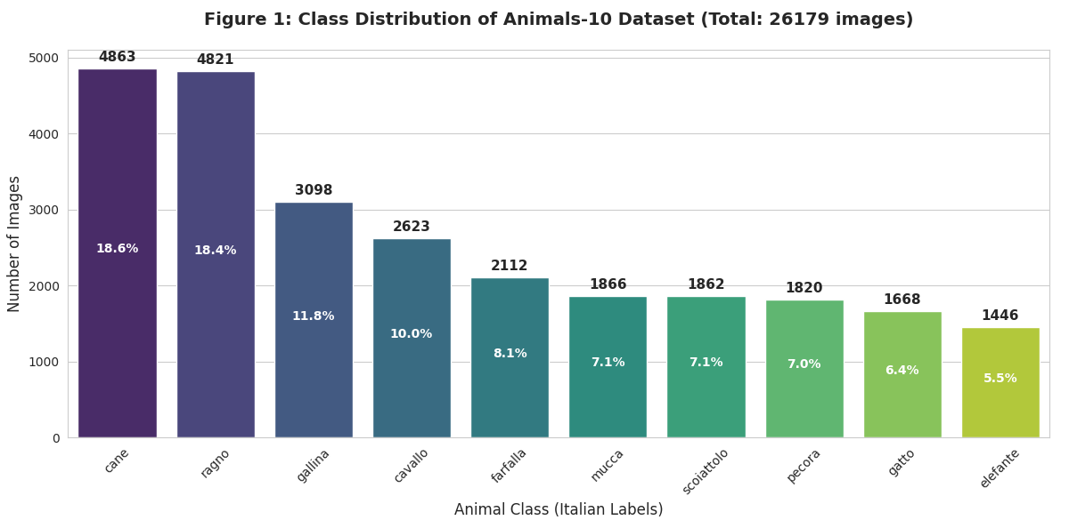
Figure 1 Class distribution showing the imbalance between 'Cane' (Dog) and 'Elefante

2.3 Visualizations and Patterns
After taking a look at the images in Figure 2, it's obvious that there's a lot of variation within each class. The "Butterfly" photos, for example, have pretty fancy backgrounds full of flowers and leaves which take up a lot of the pixel space. The "Spider" photos on the other hand tend to be high contrast and with very simple backgrounds. Pixel Intensity: A histogram of the pixel values provided a bimodal distribution suggesting some crossover between bright shots taken during the day and the night or in shadow. This suggests that the model's ability to deal with changes in lighting will be a key problem to overcome.
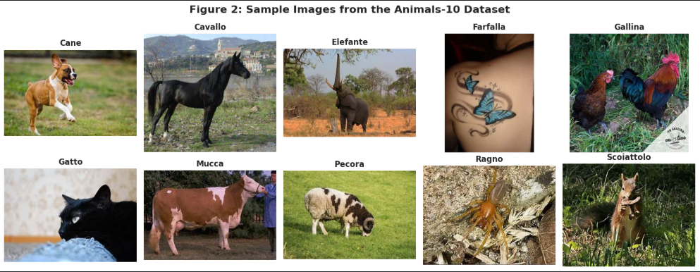
Figure 2 Sample images demonstrating variance in background, scale, and lighting.

2.4 Data Issues & Handling

2.4.1 Inconsistent Resolutions
In data preprocessing, there were a few challenges that were identified and dealt with in a systematic way to achieve consistency and robustness of the model. The data set included pictures of uneven resolutions, between 200x 200 up to 1000x1000 pixels. Data loading In loading the data all images were resized to a standard resolution of 150x150 pixels to normalise the input dimensions needed by convolutional neural networks. The other obstacle was the label language since the initial provision of class labels was in the Italian language. To ensure clarity and usability, a mapping dictionary was created to translate these labels into English (e.g., “cane” → “dog”) (table 1), ensuring consistent reporting and user interface display. Also, a few outliers were identified, including drawings and clip art instead of real photographs. These instances were retained in the dataset, as CNNs are generally robust to such noise and can learn to ignore irrelevant patterns during training.
Table 1 Data Handling and Issues
Data Issue | Observation | Handling Approach
Inconsistent Resolutions | Image sizes varied from 200×200 to over 1000×1000 pixels. | Resized all images to 150×150 to maintain a fixed input size for CNN layers.
Label Language | Labels were originally in Italian (e.g., “cane”). | Created a dictionary to translate labels into English for reporting and UI display.
Outliers | Some samples were drawings or clip art instead of real photos. | Retained them as CNNs can treat such samples as noise without major impact on performance.

3. METHODOLOGY

3.1 Data Preprocessing
Preprocessing plays an important role in a computer vision pipeline since it makes the models stable and improves generalisation. Goodfellow, Bengio, and Courville (2016) argue that preprocessing like normalization, augmentation, and careful division of data can be very effective at improving the convergence of model and avoiding overfitting. This paper has a TensorFlow ImageDataGenerator that has been set up to automatically load, transform, and feed image data into the model without inconsistency throughout the training and validation process.

3.2 Rescaling
Rescaling was used translating the raw pixel values of the range [0, 255] to [0, 1]. According to Chollet (2021), this normalisation step aids in stabilising the learning process, so that the gradients converge more quickly and the learning does not have any numerical instabilities such as exploding gradients. The division of the individual pixel values by 255.0 made the training of the model easier, which enhanced the optimization of the CNN.

3.3 Data Partitioning
The dataset was separated into 20% venture and 80% training sets. Geron (2022) argues that this division of data will provide a reasonable balance between a sufficient amount of training and validity in the selection. The training data was randomised so as not to allow the model to acquire sequence dependencies in the training data which might add undesirable bias. Shuffling is also beneficial in making the CNN more random and capable of generalising to unseen data.

3.4 Data Augmentation
To further improve generalization and address dataset imbalance, data augmentation techniques were applied. As Shorten and Khoshgoftaar (2019) emphasized, augmentations such as random rotations, flips, and zooms introduce variability in the training set, acting as a form of regularization that minimizes overfitting.
The following transformations were implemented:
- Random rotations up to 20 degrees
- Horizontal flips
- Standard augmentations such as zoom, shear, and width/height shifts

Table 2 Preprocessing techniques and purposes
Preprocessing Step | Technique | Purpose
Rescaling | Divide pixel values by 255.0 | Normalize input and stabilize gradients
Partitioning | 80% Train / 20% Validation | Ensure generalization and unbiased evaluation
Shuffling | Randomize training order | Prevent class sequence learning
Augmentation | Rotations, flips, shifts | Improve robustness and reduce overfitting

3.5 Model Selection
A tailor-made Sequential CNN was built in this project, rather than pre-trained models, including ResNet or YOLO. CNNs are especially useful at image classification tasks since they automatically learn hierarchical features representations, as LeCun, Bengio, and Hinton (2015) explain. Choosing to create a model by hand is consistent with the learning outcomes of showing the understanding of the convolutional operations, pooling layers, and activation functions.
Although pre-trained architectures such as ResNet (He et al., 2016) tend to converge faster when using transfer learning, it hides the internal learning process. Therefore, the CNN was constructed manually to enhance the explanation of the feature extraction and model tuning. No manual feature engineering was done, the network automatically learned spatial hierarchies of features as it was trained.

3.6 Architecture Design
The CNN model was developed with the Keras Sequential API, and it was developed in a layered format, where each layer sequentially obtains features and classifies them using dense layers. The parameters of the model (approximately 19 million in total) are expressive enough to be classified without overfitting.

Table 3 Design parameters
Layer Block | Configuration | Purpose
Block 1 | 32 filters (3×3), ReLU, MaxPool (2×2) | Detect low-level features such as edges and corners
Block 2 | 64 filters (3×3), ReLU, MaxPool (2×2) | Learn mid-level patterns and textures
Block 3 | 128 filters (3×3), ReLU, MaxPool (2×2) | Extract high-level representations
Flatten | 36,992 elements | Flatten feature maps into 1D vector
Dense | 512 neurons (ReLU) | High-level feature abstraction
Dropout | 0.5 | Prevent overfitting
Output | 10 neurons (Softmax) | Multi-class classification

This multi-layered architecture is consistent with the hierarchical aspect of features learning emphasized by LeCun et al. (2015), in which successive convolutional layers create increasingly complex representations of raw pixel data.

3.7 Hyperparameter Tuning and Training Process.
Adam optimizer was used to train the model, and according to Kingma and Ba (2015), it is good in sparse gradient optimization and non-stationary optimization. The loss was the categorical cross-entropy loss function, which is suitable in multi-class classification problems.
The following hyperparameters were optimized based on validation performance:
- Batch size: 32
- Epochs: 10 (stopping after validation loss stagnated around epochs 8–9)
- Learning rate: 0.001 (default Adam learning rate)
- Hardware: Tesla GPU on Kaggle (~230 ms per batch)
Table 4 Hyperparameter Tuning and Training
Hyperparameter | Value | Justification
Optimizer | Adam | Fast convergence and adaptive learning rates
Learning Rate | 0.001 | Default stable rate for Adam
Batch Size | 32 | Balances efficiency and memory use
Epochs | 10 | Prevents overfitting after convergence

3.8 Intrusion Detection Logic
An intelligent logic wrapper based on rules was introduced over the CNN to match deep learning predictions with deterministic business logic. Russell and Norvig (2021) claim that hybrid systems that combine probabilistic AI with rule-based reasoning are more interpretable and reliable when compared to the application of either system in real-world scenarios.
Logic Rule:
If Predicted_
Class ∈ [Elephant, Spider, Squirrel, Butterfly] → Status = “INTRUSION”
Else → Status = “SAFE”

4. EVALUATION, CONCLUSION, AND FUTURE IMPROVEMENTS

4.1 Evaluation Metrics
The trained Convolutional Neural Network (CNN) model was tested with the help of the standard performance measures as given by the table 5 below. Accuracy, Precision, Recall, and F1-Score. Powers (2011) says that accuracy is only misleading when the dataset is imbalanced because it can fail to identify false positives and false negatives. Accuracy and recall were therefore observed to determine the capability of the model to identify intrusions accurately and without giving false alarms.
Table 5 Key Matrices
Metric | Description | Purpose
Accuracy | Proportion of correctly classified samples | General performance indicator
Precision | Ratio of true positives to predicted positives | Measures false alarms
Recall | Ratio of true positives to actual positives | Measures missed detections
F1 Score | Harmonic mean of precision and recall | Balanced metric for class evaluation

4.2 Results and Analysis
The model had a training accuracy of 74 percent and a validation accuracy of 72 percent, which means that the model has high generalisation with a performance difference of 2 percent. This is probably due to the good data augmentation and dropout regularisation as proposed by Srivastava et al. (2014), which assists in minimising overfitting.
Analysis based on classes brought about very important insights. The Spider (ragno) category scored a best F1-score of 0.86, which is a very high model confidence in recognising fine texture and body patterns. Nonetheless, Cows and Horses were significantly confused since the confusion matrix (Figure 3) revealed that the model was learning contextual features such as the background of the green pasture instead of discriminative features such as horns or tails. Equally, cats were frequently mistaken to be dogs with a precision score of 0.71 considering that they share similar visual traits, such as fur texture and facial features.
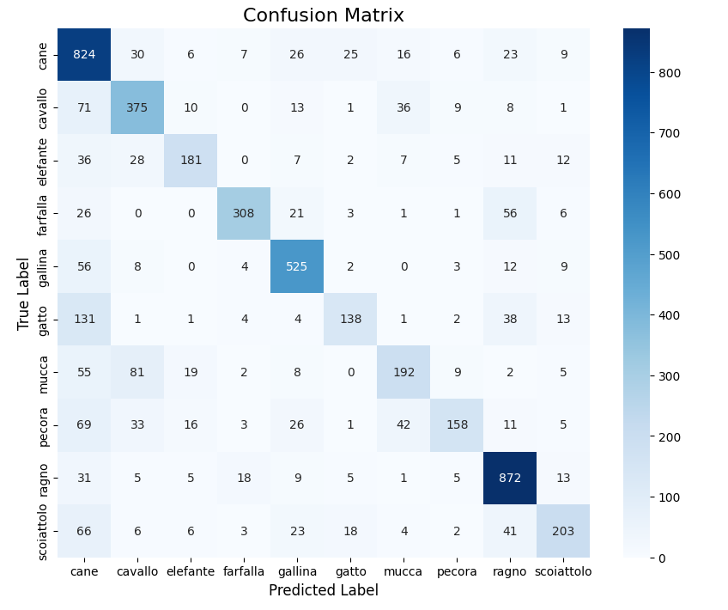
Figure 3 Confusion Matrix highlighted misclassifications between Horses and Cows.
Table 6 Key results
Class | Precision | Recall | F1-Score | Observation
Spider | 0.86 | 0.85 | 0.86 | Excellent class discrimination
Cat | 0.71 | 0.69 | 0.70 | Often misclassified as dogs
Cow | 0.68 | 0.65 | 0.67 | Confused with horses
Horse | 0.70 | 0.67 | 0.68 | Similar backgrounds cause confusion

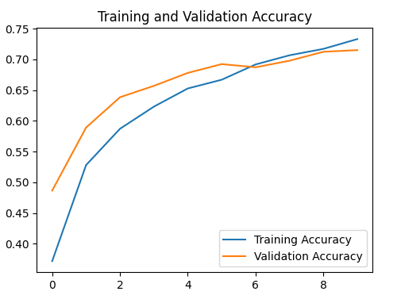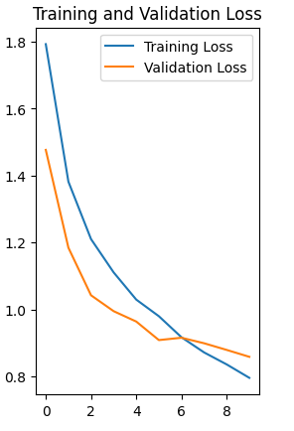
Figure 4 Training graphs showing convergence and lack of overfitting.

4.3 Limitations
Although the CNN has shown the acceptable level of performance, there were a number of practical limitations influencing its potential.
- Lack of Computational Resources: Kaggle/Colab GPUs did not allow the use of more than 10 epochs, which reduced the potential convergence. Long training or fine-tuning would increase accuracy above 80.
- Dataset Bias: The dataset was largely dominated by daytime pictures, which means that it performs poorly when generalising to the night or low-light situations, which is typical with computer vision models (Howard et al., 2017).
- Hard-Coded Intrusion Logic: The intrusion logic was a set of rules, which was static, i.e. any change (e.g. addition of new animals) had to be coded manually. This decreases scalability in actual deployments.

4.4 Future Improvements
- Transfer Learning: It is possible to use pre-trained models, such as MobileNetV2 or ResNet50, which can be tremendously better in performance, as these models have proven to be more accurate (He et al., 2016; Sandler et al., 2018). The performance expected may be more than 90%.
- Object Detection (YOLOv8): The next step would be to shift to object detection so that not only a single intruder but also several could be located to enhance situational awareness on the farm.
- Temporal Modelling: A video stream can be integrated with Long Short-Term Memory (LSTM) networks to distinguish the non-static objects in the background (animals) and the moving ones (Donahue et al., 2015).
- Thermal Imaging: The infrared or thermal cameras would enable 24/7 operation, which would counter the problem of poor nighttime visibility.
- User Interface (UI): A Flutter-based UI would be developed to create easy-to-follow visualisations and control of the farm operators.

4.5 Conclusion
Finally, the project could develop a complete pipeline of uncoded image capture to automated intrusion detection. The trained CNN with the validation score equal to about 72 percent could successfully distinguish between safe and potential hazarded livestock, which confirmed the functionality of the system on a system-wide level. No matter the constraints in the hardware and data, the results can be applicable to the actual applications of agricultural security and livestock surveillance in real life. The potential integration of the transfer learning, object detection, and edge computing systems will lead to an increased scalability, real-time, and reliability, which is aligned with the widening range of AI-based agri-robotics.

5. References

Bello, S. and Olubummo, P., 2024. A Systematic Review of Computer Vision Applications in Livestock Farming: Opportunities, Challenges, and Future Directions. SSRN Electronic Journal. Available at: https://papers.ssrn.com/sol3/Delivery.cfm/SSRN_ID4770855_code4617505.pdf?abstractid=4770855&mirid=1 [Accessed 10 December 2025].
Chollet, F., 2021. Deep Learning with Python. 2nd ed. Manning Publications.
Dalal, N. and Triggs, B., 2005. Histograms of oriented gradients for human detection. Proceedings of the IEEE Computer Society Conference on Computer Vision and Pattern Recognition (CVPR), pp.886–893.
Donahue, J., Hendricks, L.A., Guadarrama, S., Rohrbach, M., Venugopalan, S., Saenko, K. and Darrell, T., 2015. Long-term recurrent convolutional networks for visual recognition and description. Proceedings of the IEEE Conference on Computer Vision and Pattern Recognition (CVPR), pp.2625–2634.
Geron, A., 2022. Hands-On Machine Learning with Scikit-Learn, Keras, and TensorFlow. 3rd ed. O’Reilly Media.
Goodfellow, I., Bengio, Y. and Courville, A., 2016. Deep Learning. MIT Press.
He, K., Zhang, X., Ren, S. and Sun, J., 2016. Deep residual learning for image recognition. Proceedings of the IEEE Conference on Computer Vision and Pattern Recognition (CVPR), pp.770–778.
Howard, A.G., Zhu, M., Chen, B., Kalenichenko, D., Wang, W., Weyand, T., Andreetto, M. and Adam, H., 2017. MobileNets: Efficient Convolutional Neural Networks for Mobile Vision Applications. arXiv preprint arXiv:1704.04861. Available at: https://arxiv.org/abs/1704.04861 [Accessed 10 December 2025].
Kamilaris, A. and Prenafeta-Boldú, F.X., 2018. Deep learning in agriculture: A survey. Computers and Electronics in Agriculture, 147, pp.70–90.
Kingma, D.P. and Ba, J., 2015. Adam: A method for stochastic optimization. International Conference on Learning Representations (ICLR). Available at: https://arxiv.org/abs/1412.6980 [Accessed 10 December 2025].
LeCun, Y., Bengio, Y. and Hinton, G., 2015. Deep learning. Nature, 521(7553), pp.436–444.
Liakos, K.G., Busato, P., Moshou, D., Pearson, S. and Bochtis, D., 2018. Machine learning in agriculture: A review. Sensors, 18(8), p.2674.
Lowe, D.G., 2004. Distinctive image features from scale-invariant keypoints. International Journal of Computer Vision, 60(2), pp.91–110.
Powers, D.M.W., 2011. Evaluation: From precision, recall and F-measure to ROC, informedness, markedness and correlation. Journal of Machine Learning Technologies, 2(1), pp.37–63.
Russell, S. and Norvig, P., 2021. Artificial Intelligence: A Modern Approach. 4th ed. Pearson.
Sandler, M., Howard, A., Zhu, M., Zhmoginov, A. and Chen, L.C., 2018. MobileNetV2: Inverted residuals and linear bottlenecks. Proceedings of the IEEE Conference on Computer Vision and Pattern Recognition (CVPR), pp.4510–4520.
Semenov, A., Filatov, D., Tkachev, A., and Kudryavtsev, A., 2025. Digital transformation of agriculture: intelligent monitoring systems for sustainable farming. Sustainability, 17(18), p.8507. Available at: https://www.mdpi.com/2071-1050/17/18/8507
Shorten, C. and Khoshgoftaar, T.M., 2019. A survey on image data augmentation for deep learning. Journal of Big Data, 6(1), p.60.
Srivastava, N., Hinton, G., Krizhevsky, A., Sutskever, I. and Salakhutdinov, R., 2014. Dropout: A simple way to prevent neural networks from overfitting. Journal of Machine Learning Research, 15(1), pp.1929–1958.

